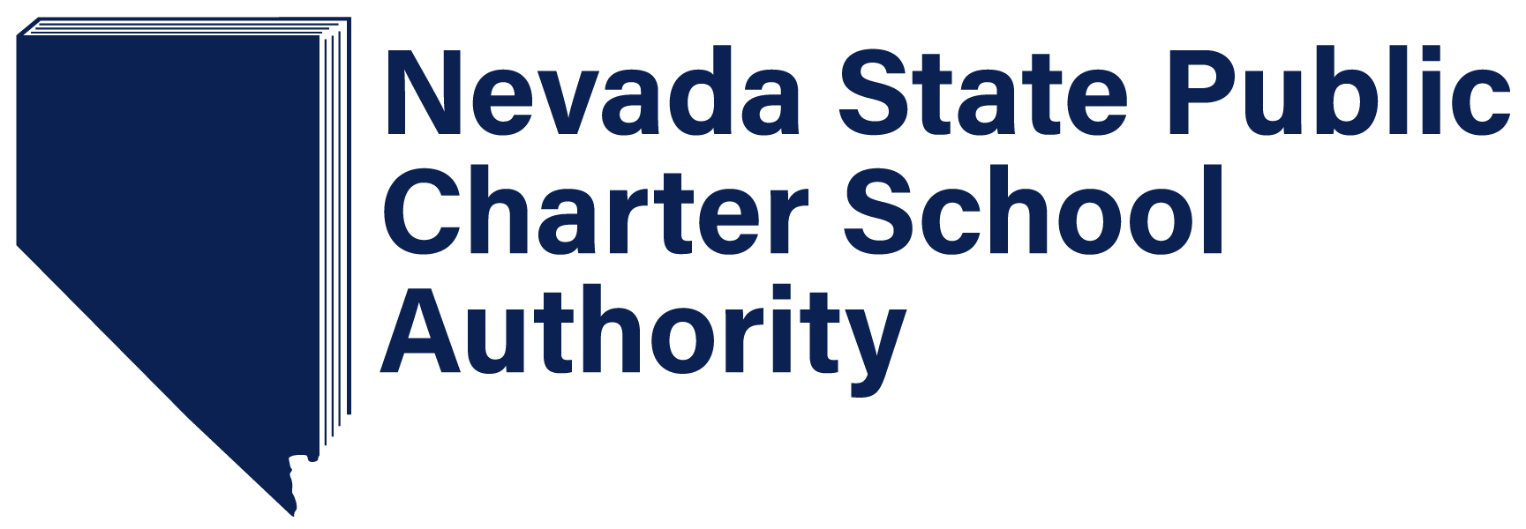

2024 Growth Management Plan
Proposed Updates: January 26, 2024
(Version 1.4)
Pursuant to NRS 388A.167 the SPCSA is required to review the Growth Management Plan at least biennially and revise the plan, as necessary. The initial Growth Management Plan was approved by the State Public Charter School Authority at the December 13, 2019, board meeting. After receiving feedback from the Legislative Committee on Education, the State Public Charter School Authority approved a revised Growth Management Plan in April of 2020, May 2021, and January 2023. This 2024 iteration of the Growth Management Plan incorporates action taken by the Authority since January 2023, provides updated data, where available, includes the most recent version of the Demographic and Academic Needs Assessment as of 2023, and includes revised and updated strategies to be used by the SPCSA.

All proposed changes are highlighted in grey.

Executive Summary
Created in 2011, Nevada’s State Public Charter School Authority (SPCSA) is a governmental agency of the State of Nevada and a statewide charter school sponsor. The SPCSA authorizes public charter schools across the state and is responsible for the oversight and monitoring of those schools to ensure positive academic outcomes for students and strong stewardship of public dollars. Data published by the Nevada Department of Education (NDE) demonstrates that, on average, SPCSA-sponsored schools academically outperform public schools statewide. Recent statewide assessment results published by the NDE show that across almost every student group, students attending SPCSA-sponsored public charter schools outperformed their state peers who attend local school district public schools. Over the last five years, the SPCSA has seen significant progress in serving a population that is representative of public school students across the State. This is evidenced by a 28% increase in the population of students who qualify for Free or Reduced-Price Lunch over five years and an 80% increase in the number of charter campuses designated as Title I in that same time period. SPCSA sponsored schools serve students with disabilities at a rate of 10.4%, just a 3.2 percentage point difference compared to public schools statewide. English Language Learners make up 10% of SPCSA students, just a 3.8 percentage point difference compared to public schools statewide. Despite the year over year growth in students who qualify for Free or Reduced-Price Lunch (FRL), the SPCSA continues to serve a lower percentage of students than the statewide average.
As outlined in the SPCSA’s five-year strategic plan approved in December of 2019, the SPCSA will build upon the strong academic performance across its schools while evolving to serve a higher percentage of students who qualify for Free or Reduced-Price Lunch, students who are English Learners, and students who receive Special Education services. Specifically, the SPCSA has established three goals:
- Provide families with access to high quality schools;
- Ensure that every SPCSA student succeeds - including those from historically underserved student groups; and
- Increase the diversity of students served by SPCSA schools.
This Growth Management Plan outlines the current performance of SPCSA-Sponsored schools, goals and plans for growth over the next five years, and proposed initiatives and actions to achieve the stated goals. The SPCSA will review and revise the Growth Management Plan at least every two years to reflect changes in the state’s educational landscape. An outline of the plan is below:
Section 1: Growth Management Plan Context
- History of Public Charter Schools in Nevada
- History of the SPCSA
- SPCSA Transition to Strategic Growth
Section 2: The Nevada State Public Charter School Authority Today
- Current Educational Models within the State Public Charter School Authority
- State Public Charter School Authority School Performance
- Demographics of Students Attending State Public Charter School Authority Schools
Section 3: The Demographic and Academic Needs Assessment
Section 4: The Future of State Public Charter School-Authority Sponsored Schools
- Five-year Strategic Goals
- Planning for Future Growth
  - Stakeholder Engagement in Planning
  - Potential Renewal of Existing Schools
  - Approved Expansions of Existing Schools
  - Potential Future Expansions of Existing Schools
  - New Schools Approved to Open
  - Potential Future New Schools
  - School Contract Termination, Closure and Nonrenewal
Section 5: The Future of State Public Charter School Authority Operations & Practices

Section 1: Growth Management Plan Context
A. History of Public Charter Schools in Nevada
During the 1997 Nevada Legislative Session, the first Nevada public charter school laws were ratified. The statute allowed for several types of entities to sponsor public charter schools, which are schools that exist outside of the typical school district construct. Public charter schools are open to all students and are governed by volunteer Boards of Directors. In addition, public charter schools are prohibited from operating for profit in the state of Nevada. Each Public Charter School is subject to a contract with a sponsor, which is responsible for providing oversight and monitoring to ensure positive academic outcomes for students and strong stewardship of public dollars.
Following the initial charter school legislation in 1997, charter schools were sponsored by entities such as local school districts, the Nevada State Board of Education, or state institutions of higher education. This sponsorship format continued through 2010.
B. History of the SPCSA
The State Public Charter School Authority (SPCSA) was created during the 2011 Nevada Legislative Session in order to:
- Authorize charter schools of high-quality throughout this State with the goal of expanding the opportunities for pupils in this State, including, without limitation, pupils who are at risk;
- Provide oversight to the charter schools that it sponsors to ensure that those charter schools maintain high educational and operational standards, preserve autonomy and safeguard the interests of pupils and the community; and
- Serve as a model of the best practices in sponsoring charter schools and foster a climate in this State in which all high-quality charter schools, regardless of sponsor, can flourish.
In addition, the SPCSA inherited the public charter schools that had previously been sponsored by the Nevada State Board of Education. At that time, the SPCSA inherited 16 school campuses and since that time has grown to sponsor 81 school campuses as of the 2023-24 school year. The Clark, Washoe, and Carson City school districts continue to sponsor a small number of charter schools directly.
Annually, the Nevada Department of Education (NDE) rates all public schools statewide on the Nevada School Performance Framework (NSPF). Under the NSPF, 1-star is the lowest rating, 5-stars is the highest rating and 3-stars is considered to be ‘adequate.’ Due to the COVID-19 Pandemic, and waivers granted by the U.S. Department of Education, the Nevada Department of Education did not issue star ratings in the 2019-2020 and 2020-2021 school year. However, for the 2021-22 school year, the Nevada Department of Education issued index scores, scores between 0 and 100 which are used in a typical year to determine star ratings. NDE did issue star ratings in the most recent 2022-2023 school year. Based on these data, nearly 73% of SPCSA-sponsored charter schools earned a star rating of 3-stars or better.
Additionally, recent statewide assessment data published by the Nevada Department of Education show that across almost every racial/ethnic and demographic student group, students attending SPCSA-sponsored public charter schools outperform their state peers in the annual state Math and English Language Arts assessments. Over the last four years, the SPCSA has seen significant progress in serving a population that is representative of public school students across the State. This is evidenced by a 28% increase in the population of students who qualify for Free or Reduced-Price Lunch over five years. Additionally, there has been an 80% increase in the number of charter campuses designated as Title I from 20 in the 2019-20 school year to 36 in the 2023-24 school year. However, despite the year-over-year growth in the population of students who qualify for Free or Reduced-Price Lunch, students who are English Learners, and students who receive Special Education services, compared to public schools statewide, the SPCSA continues to serve a lower percentage of students in these subgroups. Through its five-year strategic plan adopted in December of 2019, the SPCSA aims to build upon its current academic success while providing greater access to these student groups.
C. SPCSA Transition to Strategic Growth
In July of 2019, the State Public Charter School Authority approved its first Demographic and Academic Needs Assessment. In accordance with Assembly Bill (AB) 462 from the 2019 Legislative Session, now codified in NRS 388A.220, this Needs Assessment evaluates the demographics, academic needs and needs of students at risk of dropping out of school across the state. The SPCSA approved a revised 2024 Demographic and Needs Assessment in December of 2023 and will continue to post an updated Needs Assessment each year as required by law. The Needs Assessment has been incorporated into the SPCSA’s process for reviewing and approving new public charter school applications. While the Needs Assessment provides a snapshot in time of the needs of students in Nevada, the Growth Management Plan provides a preview of how new public charter schools will address the identified needs of students in Nevada.
Through this Growth Management Plan, the SPCSA outlines projected growth, including new charter schools, additional campuses for existing schools, grade level expansion, and anticipated charter renewals. In addition, we consider statewide pupil performance, including data for specific student groups, and the academic needs of students in geographic areas of the state. Finally, the SPCSA has chosen to include an assessment of policies, procedures, capacity and resources along with potential initiatives and actions to enable the agency to both facilitate and manage the planned growth. All of this will support the SPCSA in maintaining strong academic performance across its schools while continuing to expand charter school options statewide and working to serve a higher percentage of students who qualify for Free or Reduced-Price Lunch, students who are English Learners and students who receive Special Education services.
As part of this transition to strategic growth the SPCSA has also committed to improved communication and coordination with local school districts. To that end, SPCSA has instituted processes and procedures that formalize notification to local school districts and the Department of Education as required under Section 4 of Assembly Bill 462 (2019), now codified in NRS 388A.225. These notifications are sent to the Superintendent of Public Instruction, the local school district superintendent, and the local school district board president when the SPCSA a) receives a notice of intent to submit an application to open a new public charter school, b) receives an application to open a new public charter school, c) receives a request to amend a charter school contract, and d) approves an application to open a new charter school or to amend a charter school contract. In addition, the SPCSA Executive Director regularly attends meetings of the Nevada Association of School Superintendents and shares updates with school district superintendents during those meetings. SPCSA staff also engage regularly with school district staff through phone calls and meetings.
Additionally, the SPCSA now formally solicits feedback from the appropriate local school district on all applications for new charter schools, and on charter contract amendment applications that contemplate an expansion in enrollment and/or a new campus (although not required by NRS).
SPCSA staff also notifies local municipalities of any new school applications and requests their input. The intent is to better facilitate coordination and planning regarding zoning and traffic safety. All new charter school applications are also posted on the SPCSA website along with an input form so that any member of the public may provide input. Once received, this feedback is included in the staff review of the application and provided to the SPCSA Board when it considers action on a new school application.

Section 2: The Nevada State Public Charter School Authority Today
As of the 2023-24 school year, the SPCSA serves 61,883 students in 81 public charter school campuses that span five counties across the state. This makes the SPCSA the third largest Local Educational Agency (LEA) in the State, serving 12.7% of public school students in Nevada, just behind the Washoe County School District which serves 64,755 students. The SPCSA performs its statewide oversight, support and, sponsorship role with a staff of thirty-three full time employees split between the Carson City and Las Vegas offices.
- Current Educational Models within the State Public Charter School Authority
As stated in NRS 388A.150, the purpose of the SPCSA is to “Authorize charter schools of high-quality throughout this State with the goal of expanding the opportunities for pupils in this State, including, without limitation, pupils who are at risk.” By offering a variety of school models, the SPCSA enables Nevada families to choose schools that best align with the needs and interests of their children. Today, SPCSA schools include, but are not limited to, the following models:
- Arts Integration  - Montessori  - Bi-lingual education  - Career and technical education  - Alternative high school serving under-credited students  - Educational models aimed at meeting the needs of young women | - Dual enrollment high schools  - Online or blended learning  - Classical education  - STEM/STEAM education  - Project-based learning
- State Public Charter School Authority School Performance
Nevada School Performance Framework (NSPF) Star Ratings from the 2022-2023 school year show that 73% of SPCSA-sponsored schools earned a 3-star rating or better by earning an index score of 50 or greater. The Nevada Department of Education defines a 3-star rating as ‘adequate’, or meeting expectations. Additionally, during the 2022-2023 school year, 32% of SPCSA-sponsored schools earned the highest possible rating of 5 stars, and 15% of schools earned a 4-star rating, compared to the statewide rate of 11% 5-star schools and 10% 4-star schools.
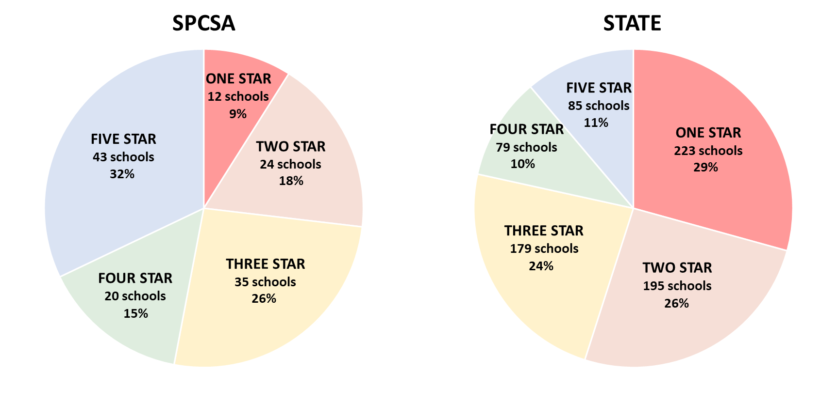
When considering Title I schools, those schools that serve a high percentage of students in poverty, the SPCSA continues to see a high rate of schools performing at or above a 3-star performance level or better. As of the 2022-2023 school year, 53.8% of SPCSA-sponsored Title I charter schools earned a 3-star rating or higher, while 26.5% of Title I schools across the state earned 3-star rating or higher. Although SPCSA-sponsored Title I schools continue to outperform Title I schools statewide, SPCSA-sponsored Title I charter schools tend to underperform non-Title I charter schools, demonstrating a need to continue to close opportunity gaps between students attending Title I and non-Title I schools.
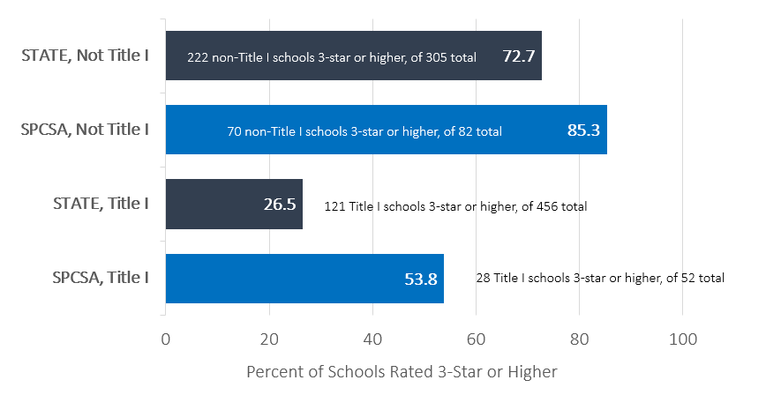
While the vast majority of SPCSA-sponsored schools are meeting or exceeding performance expectations, there are still schools that fall short. According to the Nevada School Performance Framework index scores for the 2022-2023 school year, approximately 27% of SPCSA-sponsored schools earned a 1- or 2-star rating. In instances in which an SPCSA-sponsored school is not meeting academic expectations, the SPCSA responds with appropriate intervention. This may include issuing a formal notice to a school, requiring a school improvement plan, conducting additional monitoring, or, in instances of persistent low performance and/or circumstances that undermine the health and safety of students, closing a school. At its November 3, 2023, and December 8, 2023, board meetings, the SPCSA voted to conduct additional monitoring of 12 SPCSA-sponsored schools due to concerns with academic performance by issuing a formal Notice of Concern This includes a heighted review of each school’s School Performance Plan (SPP), along with mid-year status checks on the progress in implementing these plans. However, due to inflated growth metrics resulting from COVID-19 testing data in the 2020-2021 and 2021-2022 school years, it was determined that only 1-star schools would be issued these formal Notices.
The Authority will continue to be transparent about performance expectations for all current and future schools. By utilizing the findings of the Demographic and Academic Needs Assessment and implementing strategic oversight measures, the Authority firmly believes it can fulfill its statutory purpose by cultivating more high-quality public charter schools throughout Nevada and enable equitable access to students of all backgrounds.

- Demographics of Students Attending State Public Charter School Authority Schools
As of the October 2, 2023 student count, 61,883 students were enrolled in SPCSA-sponsored schools. Overall, 50.9% of students qualify for Free or Reduced-Price Lunch, 10% of students are English Learners, and 10.4% are students who receive Special Education services. As shown in the graphs below, compared to the state, the SPCSA serves a lower percentage of students in these three student groups, all of which have been historically underserved. However, the SPCSA has seen steady increases in these student populations and is within a few percentage points in Students with Disabilities and English Learners. The SPCSA has also made significant progress in recent years toward serving a population representative of the state with regard to race and ethnicity, now serving a comparable percentage of students identifying as Black, Pacific Islander and White. SPCSA-sponsored schools continue to serve a lower percentage of students that identify as Hispanic/Latino compared to overall statewide student demographics.
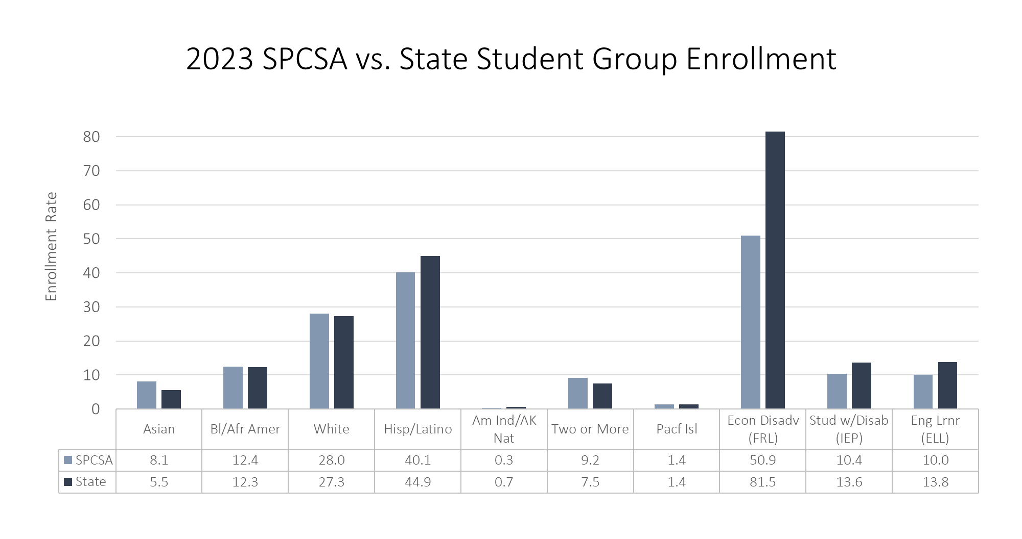
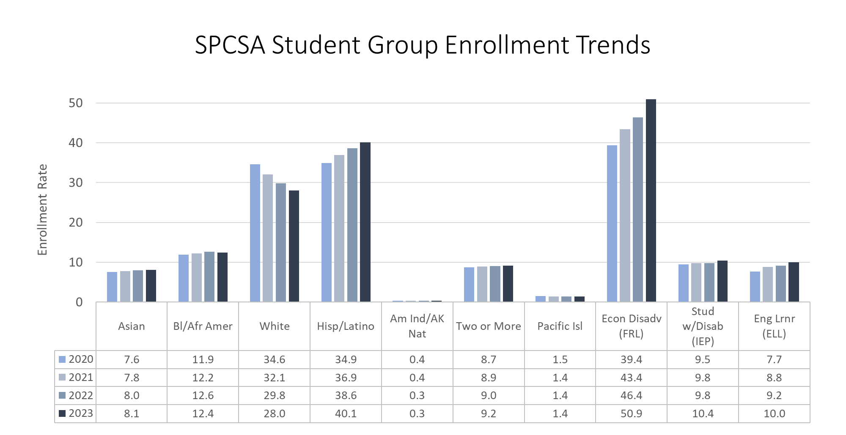

Section 3: The Academic and Demographic Needs Assessment
In 2019, the Nevada State Legislature voted to pass Assembly Bill (AB) 462. In part, this legislation directed the Nevada State Public Charter School Authority (SPCSA) to annually conduct and incorporate the findings of “an evaluation of demographic information of pupils, the academic needs of pupils and the needs of any pupils who are at risk of dropping out of school in this State” into its charter school authorizing decisions—requirements codified in Nevada Revised Statute (NRS) 388A.220 and 388A.249.
The deadline for the first evaluation was established as July 30, 2019, with a requirement that the evaluation be updated annually by January 31. To this end, the SPCSA conducted an Academic and Demographic Needs Assessment in collaboration with the Nevada Department of Education (NDE) as well as local school districts, and the Authority board approved the first Academic and Demographic Needs Assessment on July 26, 2019. During the fall of 2019, the NDE released updated Nevada School Performance Framework (NSPF) ratings and demographic data, and this information was incorporated into the December 2019 version of the Needs Assessment. Due to the COVID-19 pandemic, the NDE was granted 2019-20 and 2020-21 school year waivers from the U.S. Department of Education for certain school accountability requirements established under the federal Every Student Succeeds Act (ESSA). Accordingly, the NDE did not calculate the annual NSPF school star ratings for either the 2019-20 or 2020-21 school years. For the 2021-22 school year, the NDE was granted a waiver from the U.S. Department of Education allowing the NDE to issue index scores, but not official star ratings. NDE did release 2022-2023 Nevada School Performance Ratings and those ratings are incorporated into the 2024 Demographic and Academic Needs Assessment approved by the board December 8, 2023.
The Needs Assessment document details how the SPCSA has defined academic and demographic need, the findings of the Needs Assessment, and the implementation of the Needs Assessment.
The SPCSA worked in conjunction with local school districts and the NDE to establish definitions for demographic and academic needs that are transparent, grounded in student and school performance, and aligned to the Department’s school accountability system. While the identified needs remain largely the same, this iteration of the Academic and Demographic Needs Assessment incorporates recent feedback from representatives of school districts, representatives from the Nevada Department of Education, and Authority members regarding the definitions of need. Additional feedback may be incorporated in future iterations.
The SPCSA has defined demographic and academic needs as follows:
  - Demographic Needs
Student groups that consistently underperform on the Nevada state assessments in Math and ELA (3rd-8th grade Smarter Balanced and 11th grade ACT) present a demographic need. Such student groups may benefit from the creation of high-quality charter school options so long as those new charter schools have credible plans to meet their needs.
Applicants meeting this need will propose a school model that includes demonstrated capacity, credible plans, community input, and thorough research and analysis to intentionally enroll and serve the following student groups, each of which has been identified as historically underperforming.
    - Students qualifying for free or reduced-price lunch (FRL)
    - English Language Learners (ELLs)
    - Students with disabilities (those with an Individual Education Program, or IEP)
    - Students in foster care
    - Students experiencing homelessness
Successful applicants will demonstrate the capacity to support these student groups in making rapid academic growth and achieving academic performance above the state average. Applicants intending to enroll and serve student groups that have historically underperformed can be most impactful when they alleviate barriers to access. Examples include, but are not limited to, providing meals through the National School Lunch Program (NSLP), providing student transportation, proactively translating communications to relevant languages, and offering robust social work and counseling services.
  - Academic Needs
- Geographies with Consistently Underperforming Schools
Zip codes with one or more consistently underperforming schools present an academic need. When a significant number of students are enrolled in schools that have a history of not meeting or partially meeting state performance standards, a community may benefit from the addition of high-quality charter school options so long as those new charter schools have both credible plans to meet the needs of the student population and strong partnerships within the community.
Applicants meeting this need will propose a school model that includes demonstrated capacity, credible plans, community input, and thorough research and analysis to intentionally provide access to 3-, 4- and 5-star schools in zip codes where a significant percentage of students are attending consistently underperforming schools, which are defined as schools that:
- Received a 1- or 2-star NSPF rating for the 2022-23 school year, AND
- Received an NSPF index score below 50 for the 2021-22 school year.
Successful applicants will demonstrate the capacity to effectively meet the needs of students who will transfer from consistently underperforming schools to drive rapid academic growth and achieve academic performance above the state average. Additionally, applicants meeting these needs will provide intentional plans for partnering with the community and building on identified community assets to meet the needs of students within the community. Simply adding a school option in a community with consistently underperforming schools will not inherently meet community needs. Rather, schools must establish trust by working with the community to intentionally meet the needs of the students and community. Alternative 3-, 4- or 5-star school options in communities where a significant percentage of students are attending a consistently underperforming school can be most impactful when there are limited or no public charter school options available in the community.
- Students At Risk of Dropping Out of School
Student groups that graduate from high school at lower rates (i.e. drop out at higher rates) than their peers present an academic need. Nearly one in five Nevada students do not graduate from high school in four years, with certain student groups consistently graduating at lower rates than their peers, including English Language Learners (ELLs), students with disabilities (those with Individualized Education Programs or IEPs), students that are homeless, students in foster care, and students identifying as American Indian/Alaskan Native, Black/African American, or Hispanic/Latino. Such students may benefit from the creation of high-quality charter school options so long as those new charter schools have credible plans to meet their needs.

Applicants meeting this need will propose a public charter school model that includes demonstrated capacity, credible plans, community input, and thorough research and analysis to enroll and prevent at-risk students from dropping out of school and put them on track for successful high school completion with concrete post-secondary plans toward economic success. Models may include, but are not limited to, programs designed for student groups that are most at risk of dropping out or credit-deficient students to get back on track to graduate. Applicants should demonstrate a strong understanding of grade-level appropriate indicators for successful high school completion, such as early literacy, attendance, and credit sufficiency, as well as plans to enable students to successfully meet these milestones. Charter schools aimed at enrolling and preventing at-risk students from dropping out of school can be most impactful when they offer a unique academic experience for students and/or are closely aligned to Nevada’s priorities for workforce and economic development.

NRS 388A.249 requires that approval of any charter application must include a determination that the proposed school meets one or more of the needs defined in the Academic and Demographic Needs Assessment. Therefore, the SPCSA must evaluate charter applications based upon the public charter school application rubric which includes evaluating the proposed school’s plans to meet statewide academic and demographic needs identified in the SPCSA’s Needs Assessment. SPCSA staff will make recommendations based on the approach outlined in the visual below. Ultimately, the Authority Board will vote to approve or deny an application.

Applicant does not meet either an academic need or a demographic need.  Applicant may need to revise their academic plan or pick a new location in order to qualify for a recommendation - even if their application otherwise meets the standards set forth by the SPCSA in its application rubric. | Applicant meets one or more academic needs OR one or more demographic needs.  Applicant may be recommended for approval by SPCSA Staff contingent upon the details of their application and may be subject to additional contract conditions, so long as their application otherwise meets the standard set forth by the SPCSA in its application rubric. | Applicant meets one or more academic needs AND one or more demographic needs.  Applicant will likely be recommended for approval by SPCSA staff so long as their application otherwise meets the standards set forth by the SPCSA in its application rubric.
 |  | Likelihood applicant is approved
The Needs Assessment is updated annually, in collaboration with the NDE and local school districts, to ensure that each charter application process is reflective of the state’s current academic and demographic needs. The SPCSA is most likely to approve high quality applications that address the needs identified in the Needs Assessment. In reviewing and approving charter applications, the SPCSA will solicit input and feedback from local school districts, municipalities, other key stakeholders, and the public at large.

Section 4: The Future of State Public Charter School-Authority Sponsored Schools
- Five-Year Strategic Goals
Aligned to the SPCSA five-year strategic plan, the SPCSA is focused on three primary goals to further the SPCSA vision of equitable access to diverse, innovative, and high-quality public schools for every Nevada student.
Goal 1: Provide Families with Access to High-Quality Schools
The SPCSA aims for all sponsored schools to meet academic, organizational, and financial performance standards. Five-year goals:
- Improve upon existing strong performance on star ratings by achieving 70% four-star or better, 83% three-star or better, no more than 17% two-star, and less than 4% one star.*
- Schools demonstrate strong organizational and financial performance with 95% rated as meeting standards on the SPCSA Organizational and Financial Performance Frameworks.
Goal 2: Ensure that every SPCSA student succeeds - including those from historically underserved student groups
The SPCSA aims for all sponsored schools to demonstrate strong academic growth, high levels of proficiency and on-time graduation across all student groups, including historically underserved student groups. Five-year goals:
- Increase the percent of schools that demonstrate, for each student group, a median student growth percentile on the 3rd-8th grade state Math and English Language Arts (ELA) assessments that exceeds the respective group’s Nevada median student growth percentile.
- For each student group, surpass respective Nevada proficiency rates on the state Math and ELA assessments.
- For each student group, surpass respective Nevada 4-year graduation rates.
Goal 3: Increase the diversity of students served by SPCSA schools
The SPCSA aims for sponsored schools to serve a population of students that is representative of the State with regard to race/ethnicity and additional student groups. Five-year goals:
- By the 2021-22 school year and thereafter, in newly created SPCSA-sponsored public charter school seats (new schools, new campuses, and expansion of existing schools), enroll English Learners, Students Eligible for Free or Reduced-Price Lunch, and Students with Disabilities at rates that are greater than or equal to the respective Nevada enrollment rates.^
- While continuing to serve currently enrolled students, in vacant seats at existing SPCSA-sponsored schools, enroll English Learners, Students Eligible for Free or Reduced-Price Lunch, and Students with Disabilities at rates that are greater than or equal to the respective Nevada enrollment rates.^
*This goal excludes alternative framework schools
^Applies to SPCSA-sponsored schools on the aggregate level, and not on the individual school level
Annual benchmarks that are used to track progress toward achieving these goals are included in Appendix B.

Goal 1: Provide Families with Access to High Quality Schools
When the SPCSA’s Strategic Plan was adopted during the 2018-19 school year, the vast majority of SPCSA-sponsored charter schools were already meeting expectations for academic performance by earning a 3-star rating or better and a significant percent were exceeding the expectations by earning a rating of 4-stars or better. The SPCSA aimed to continue to build on this high performance by increasing the percent of schools rated as 3-stars or better. Over the last four years, SPCSA-sponsored schools, like schools across the State, have seen significant challenges due to the impacts of COVID-19. During that time, we’ve also seen an increase in the number of SPCSA-sponsored schools and students served by SPCSA schools. There has been a decrease in the percentage of schools that earned a rating of 3-stars or better. As the State’s education system continues to rebound from the effects of COVID-19, the SPCSA aims to continue to increase the number of schools rated as 3-stars or better, while moving more schools from the 3-star level to the 4- and 5-star level to be on track to meet goals set forth for the 2023-24 school year.
The table below shows the SPSCA’s progress in meeting academic performance goals (excluding those schools that are approved to be rated on the Alternative Performance Framework).
School Year | Percent of schools rated as 1-star on the NSPF indicating they ‘do not meet standards’ | Percent of schools rated as 2-star or lower on the NSPF indicating they have ‘partially met’ standards | Percent of schools are rated 3+ stars on the NSPF indicating ‘adequate’ or better performance | Percent of schools rated 4+ stars on the NSPF indicating ‘commendable’ or ‘superior’ schools
2018-19 | 2.0% | 19.9% | 78.2% | 64.4%
2019-20^ | - | - | - | -
2020-21^ | - | - | - | -
2021-22* | 6.4% | 13.5% | 80.2% | 55.6%
2022-23 | 8.2% | 26.3% | 73.6% | 47.3%
2023-24 Goal | Less than 4% | No more than 17% | 83% or more | 70% or more
^ For the 2019-20 and 2020-21 school years, the Nevada Department of Education was granted a waiver by the U.S. Department of Education and was not required to issue star ratings under Nevada School Performance Framework.
*Projected ratings based on Nevada School Performance Framework index scores, as official 2021-22 star ratings were not issued.
In line with the responsibility to ensure strong stewardship of public funds, the State Public Charter School Authority annually evaluates the organizational and financial performance of schools. These evaluations are based on organizational and financial performance frameworks which are grounded in statutory and regulatory requirements and incorporate data from each charter holder’s annual financial audit. The SPCSA has set a goal that 95% of schools will be rated as meeting standards on both the organization and financial performance frameworks. The table below shows the progress the SPCSA has made in achieving goals related to organizational and financial performance of sponsored schools.
School Year | Percent of schools meeting organizational performance expectations | Percent of schools meeting financial  performance expectations
2019-20 | 100% | 91.2%
2020-21 | 100% | 94.7%
2021-22* | 100% | 78%
2022-23 | 95% | *
2023-24 Goal | 95% | 95%
*Financial performance results are still being evaluated and data will be added once available.
Goal 2: Ensure that every SPCSA student succeeds - including those from historically underserved student groups
Statewide data show that some student groups have historically underperformed relative to their peers on key academic indicators. Those student groups include students qualifying for Free or Reduced-Price Lunch, English Language Learners, and students who receive Special Education services, along with student identifying as Native American, Black or African American, and Hispanic or Latino. While these opportunity gaps exist within SPCSA-sponsored schools, students attending SPCSA-sponsored schools have mostly outperformed their peers on statewide assessments over the last few years. The graphs below show the percentage point differences in proficiency and graduation rate between the SPCSA and corresponding state student groups from the 2022-2023 school year.

A difference could not be calculated (rates below 5%).
ELA
MATH
A difference could not be calculated due to state rates <5% and/or small SPCSA population sizes.
To protect student privacy, differences not calculated due to small SPCSA population size.
Ultimately, the SPCSA aims to increase proficiency rates across all student groups, while narrowing any achievement gaps that currently exist. In addition to establishing goals to outpace state proficiency across each student group, growth in early grade levels is critical to putting students on track for high school. To that end, the SPCSA has set the following performance targets:
- Increase the percent of schools that demonstrate, for each student group, a median student growth percentile on the 3rd-8th grade state Math and English Language Arts (ELA) assessments that exceeds the respective group’s Nevada median student growth percentile.
- For each student group, surpass respective Nevada proficiency rates on the state Math and ELA assessments.
- For each student group, surpass respective Nevada 4-year graduation rates.
Goal 3: Increase the diversity of students served by SPCSA schools
As shown in the graph below, over the last four years, the SPCSA has increased enrollment in three historically underserved student groups: students eligible for Free or Reduced Lunch (FRL), English Learners (EL), and students who receive Special Education services (IEP). However, there is still work to be done to ensure that SPCSA-sponsored schools are serving a population that is representative of the state.
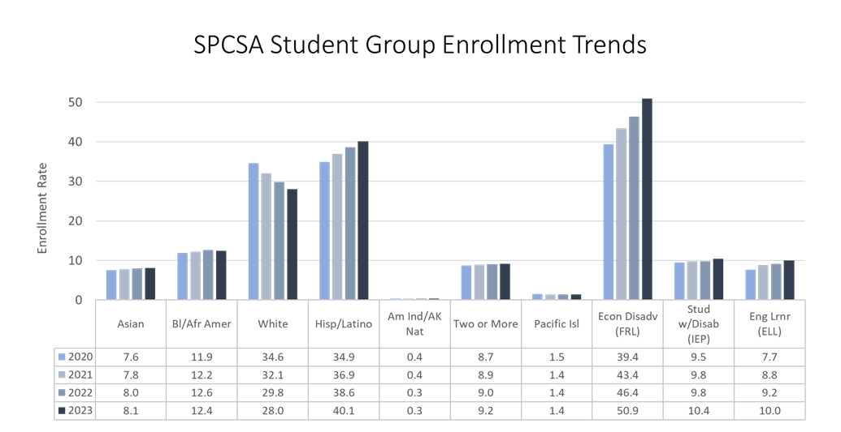
The SPCSA aims to serve a population of students that is representative of the state in terms of all student groups. To evolve the demographics of the students served by SPCSA-sponsored public charter schools, the SPCSA and schools will focus on enrolling new students that are representative of the state’s demographics as a whole.
Specifically, by the 2023-2024 school year, the SPCSA aimed to enroll FRL, EL and IEP students at a rate that is greater than or equal to the statewide average. First, when considering all new seats created through the opening of new schools, new campuses in school networks, and expanded schools, the SPCSA’s goal is for the rate of enrollment of these student groups to be equal to or higher than the statewide average beginning in the 2020-2021 school year. Second, by the 2023-2024 school year, the SPCSA aimed to enroll FRL, EL and IEP students at a rate that is equal to or higher than the statewide average in vacant seats at existing schools while enabling current students to continue to attend.
In addition, the SPCSA acknowledges that as we work to diversify the population of students served, it is important that schools simultaneously work to diversify their teaching staffs to better reflect the communities that they serve. To that end, the SPCSA has amended its new school application to ascertain how prospective schools would recruit and hire teachers and staff that are representative of the student body.
B. Planning for Future Growth
In building a plan to realize these goals, the SPCSA considered the current needs of students throughout Nevada, both through the lens of the Academic and Demographic Needs Assessment and through gathering input from community stakeholders. Specifically, this section will provide projections regarding:
- The charter schools whose charter contracts will expire;
- Additional campuses of charter schools;
- Charter schools that will expand their grade configuration or otherwise increase enrollment;
- Additional campuses of charter schools; and
- New charter schools.
- Stakeholder Engagement in Planning
To engage stakeholders in the initial development of the Growth Management Plan, the SPCSA engaged in a multi-pronged outreach process during the fall of 2019. The purpose of these outreach efforts was to gather input from stakeholders on the needs of Nevada students, and the implications of both for SPCSA growth management planning. An overview of this outreach effort is shown below:
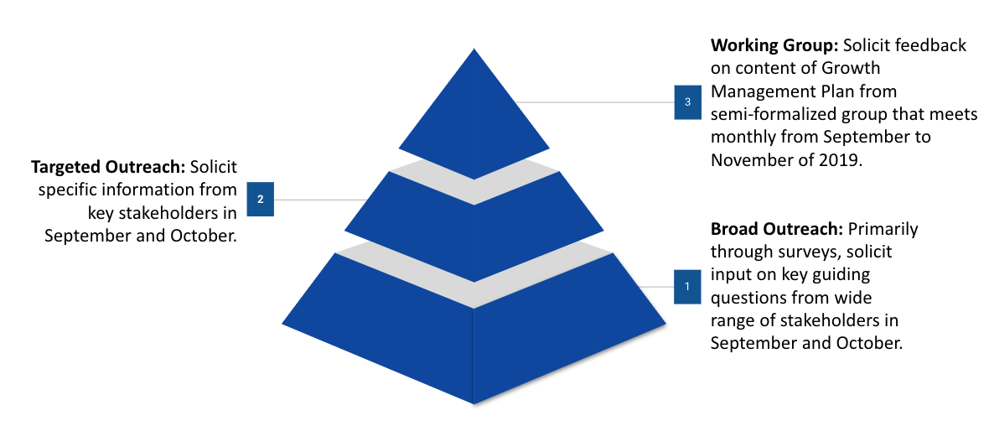
Information collected through stakeholder feedback has informed the SPCSA’s approach to this Growth Management Plan and the projections outlined below. In addition, the SPCSA continues to meet with the Nevada Department of Education and local school districts regarding updates to the Growth Management Plan and holds quarterly meetings of the Community Working Group to gather feedback and ensure alignment with other stakeholders.
- Potential Renewal of Existing Schools
Each public charter school operates under a charter contract. The initial term for all charter contracts is six years while subsequent terms can range from three to ten years. In the final year of a charter contract term, the SPCSA evaluates the academic performance, financial solvency, and organizational compliance of schools to determine whether to renew the contract. This includes reviewing data and information going back to the inception of the school, including but not limited to: academic, financial and organizational performance ratings; site evaluation reports; and regular compliance submissions. The factor most heavily weighted in determining whether to renew a school is academic performance. Specifically, the Authority board holds schools accountable for consistent performance that is ‘adequate,’ or is 3 star-rated or higher, during the renewal process. In November of 2023, the SPCSA Board approved the renewal of three charter contracts for terms ranging from three to nine years. Below is a summary of charter contracts that will expire over the next five years and performance of the schools under those contracts. Additional details are available in Appendix C.

 | Contract Ending June 2025 | Contract Ending June 2026 | Contract Ending June 2027 | Contract Ending June 2028 | Contract Ending  June 2029
# of Charter Contracts Up for Renewal | 8 | 11 | 8 | 8 | 6
% of School Campuses Up for Renewal With Star Rating of 3 or Higher | 83.7% | 72.2% | 33.3% | 54.5% | 83.3%*
*Two schools have not been rated on the NSPF as of December 2023
- Approved Expansions of Existing Schools
Existing charter schools that are sponsored by the SPCSA may submit a charter school contract amendment application to the SPCSA – which is reviewed by SPCSA staff and must be approved by the SPCSA Board – in order to, among other things, increase enrollment, add grade levels above and beyond what the charter school is approved to serve, or add a new campus. When considering an application for expansion, the SPCSA considers the academic, organizational, and financial performance of the charter holder along with the performance of other charter schools that contract with the same Charter Management Organization (CMO) or Educational Management Organization (EMO).
There are a variety of ways that a school can expand, such as adding a new campus that was not approved in the original application, adding new grade levels to an existing campus, or increasing the number of students served at their current campus. Regardless of the type of expansion sought, the SPCSA conducts a rigorous review of the current academic, financial and organizational performance along with vetting the proposed plan for expansion outlined in the amendment application. The amendment application process culminates with a recommendation to the SPCSA Board which ultimately decides whether to grant the expansion amendment. The following charter holders have been approved by the Authority Board for expansion:
Charter Holder | Location | Type of Expansion | Year of Expansion Approval | Number of Seats Added in First Year | Number of Seats Added at Full Scale
Beacon Academy of Nevada | Clark County | Expand enrollment in existing grade levels at the East and West Campus at the beginning in the 2023-24 school year. | 2023 | 46 | 232
Equipo Academy | Clark County | Expand enrollment in existing grade levels (6-12) and facilities beginning in the 2023-24 school year. | 2023 | 119 | 184
Oasis Academy | Churchill County | Expand to a new facility for high school students for the 2024-25 school year with the same approved enrollment (825) | 2023 | 0 | 0
Young Women’s Leadership Academy | Clark County | Added 8th grade for the 2023-24 school year with the same approved enrollment cap (300) | 2023 | 0 | 0
Elko Institute of Academic Achievement | Elko County | Added additional seats in current grades served. | 2024 | 308 | 396
New public charter schools frequently choose to gradually expand, oftentimes adding one grade level at a time until they reach the intended grade configuration for the school. For those schools, there is gradual enrollment growth in the initial years of operation until they have reached their final configuration.
Below is a list of schools that were authorized as slow growth schools that will continue to grow over the coming years.
- Battle Born Academy currently serves students in grades K-7 and will serve students in grades K-8 next year.
- CIVICA currently serves students in grades K-9 and will add a grade per year until the school serves students in grades K-12.
- Coral Academy of Science Las Vegas – Cadence Campus currently serves students in grades K-9 and will add a grade per year until the school serves students in grades K-12.
- Pinecrest Academy Virtual currently serves students in grades 6-11 and will add a grade per year until the school serves students in grades 6-12.
- Sage Collegiate currently serves students in grades K-6 and will add a grade per year until the school serves students in grades K-8.
- Strong Start Academy currently serves students in grades K-3 and will add a grade per year until the school serves students in grades K-5.
- TEACH Las Vegas currently serves students in grades K-8 and will add a grade per year until the school serves students in grades K-12.
- Young Women’s Leadership Academy currently serves students in grades 6-10 and will add a grade per year until the school serves students in grades K-12.

- Potential Future Expansions of Existing Schools
During the fall of 2022, the SPCSA surveyed current charter holders regarding their plans to request an amendment to expand within the next five years. Below are details regarding the types of expansion that charter holders were considering at the time the survey was administered. In considering approval of expansions, the SPCSA will be focused on achieving the five-year strategic goals and therefore will consider the degree to which expansion of existing schools will bring the agency closer to its goals.
 | Charter holders* responding that they are planning to request an amendment to expand within the next five years. | Charter holders* responding that they may request an amendment to expand within the next five years.
# of Charter Holders considering request for New Campus | 6 | 8
# of Charter Holders considering request for Additional Grade Levels | 3 | 3
# of Charter Holders considering request for Additional Seats | 6 | 4
# of Charter Holders considering request to Reduce Seats | 0 | 1
*Some charter holders are represented multiple times in the table.
- New Schools Approved to Open
In order to open a public charter school, an applicant must go through a rigorous application process. First, the applicant must submit a notice of intent, followed by a completed charter school application. The application addresses four main areas including Academic, Operations, Financials, and Meeting Community Need. Applicants that intend to affiliate with a Charter Management Organization or Educational Management Organization must also complete an addendum section to provide information about the organization’s past performance, scale strategy, capacity for growth, and the proposed relationship with the local school. The application must also include basic information about the proposed school, including members of the committee to form, proposed enrollment, and proposed opening date. The application is then vetted by a review team using the established rubric criteria. As part of the application process, the SCPSA conducts a capacity interview with the committee to form to elicit any necessary clarifications or additional information about the proposed charter school and determine the ability of the applicants to establish a high-quality charter school.
Once SPCSA staff has completed its review of the application, capacity interview with the applicant, and considered all input from local school districts, municipalities and the public, SPCSA staff provide a recommendation memo to the SPCSA Board. In this recommendation memo, SPCSA staff share the final ratings for the application based on the rubric criteria, outline strengths and concerns within the application, and communicate staff’s assessment as to whether the application should be approved. This memo, along with all application materials and feedback, are provided to the board and posted on the SPCSA website.
If an application is denied, SPCSA staff follow the procedures outlined in NRS 388A.255. This includes issuing a formal notification to the applicant of denial and then meeting with the applicant to “confer on the method to correct the identified deficiencies.” The applicant has 30 days from the receipt of the notification of denial to resubmit their application to the SPCSA. If the SPCSA denies an application after resubmission, the applicant then may appeal to the district court in which the proposed school would be located.
If a new school application is approved, the applicant is required to fulfil the SPCSA’s pre-opening requirements to secure approval to open. These pre-opening requirements cover preparedness across key functional areas including board governance, enrollment, student and family information, personnel, financial management, school operations, academic program, and facilities.
The following schools have been approved to open in the fall of 2024:
School | Location | Year Opening | First Year Enrollment | First Year Grade Configuration | Enrollment at Full Scale | Grade Configuration at Full Scale
Vegas Vista | Clark County | 2024-2025 | 200 | K-3 | 600 | K-8
Thrive Point Academy | Clark County | 2024-2025 | 300 | 9-12 | 450 | 9-12
Pioneer Technical Arts Academy | Clark County | 2024-2025 | 257 | K-8 | 1478 | K-12
Rooted School Las Vegas | Clark County | 2024-2025 | 180 | 9-10 | 360 | 9-12
Do and Be Arts Academy of Excellence | Clark County | 2024-2025 | 280 | K-3 and 6 | 630 | K-8
- Potential Future New Schools
While it is challenging to predict exactly how many charter applications the SPCSA will receive and how many of those will be approved in the coming years, data from prior years below provide some insights into recent trends.
 | 2018 | 2019 | 2020 | 2021 | 2022 | 2023
Letters of Intent Received | 37 | 32 | 27 | 44 | 23 | 12
Applications Received | 2 | 10 | 7 | 12 | 5 | 6
Approvals by Authority Board | 0 | 3 | 4 | 4 | 2 | 5
Note that some applicants may have submitted letters of intent and may have applied in multiple years.
The SPCSA remains focused on realizing the five-year strategic goals and thereby providing equitable access to high-quality, public-school options for students across Nevada. To achieve these goals, the SPCSA expects to add new schools when they demonstrate a strong plan and capacity to effectively serve students, align with the needs assessment as required by NRS 388A.249(3) and promote the strategic priorities. Over the last six years, the SPCSA has received 42 applications and approved 18 of those applications, approximately 43%. While the SPCSA is confident in the expectations set forth in the new charter school application rubric, as described in Section 5, the SPCSA is exploring ways to increase the number of applicants that meet those expectations and demonstrate readiness to open a high-quality public charter school.
- School Closure and Nonrenewal
As a charter school authorizer, the SPCSA is responsible for holding SPCSA-sponsored charter schools accountable for meeting academic, financial, and organizational performance standards. In instances in which an SPCSA-sponsored school is not meeting expectations, the SPCSA responds with appropriate intervention. This may include issuing a notice to a school, and the SPCSA generally employs a three-tiered system of intervention. The first tier is a Notice of Concern which may be issued for weak financial, organizational or academic performance. Typically, if a school that was previously performing above 3-stars receives a 1- or 2-star rating, that school is issued a Notice of Concern. The second tier is a Notice of Breach which may be issued for a) continued evidence and/or significant evidence of weak financial, academic, or organizational performance, b) failure to make substantial progress towards remedying previously identified concern, or c) failure to comply with applicable laws, regulations and/or the terms of the charter contract. Typically, a school that receives a second consecutive rating below 3-stars is issued a Notice of Breach. At each of these levels of intervention, the SPCSA may require the charter school to take certain actions, such as submit and implement an improvement plan. The SPCSA closely monitors the progress of school operating under a Notice of Concern or a Notice of Breach. The third tier is a Notice of Intent to Revoke which will initiate the process to terminate a school contract and close a school. A Notice of Intent to Revoke may be issued in instances such as persistent low performance, and/or circumstances that undermine the health and safety of students.
There are two statutes that outline circumstances in which a charter contract can be terminated. Under NRS 388A.300, a sponsor must terminate a contract if, in a period of five years, the school receives three 1-star ratings. A sponsor may also terminate a charter contract in other circumstances including, three one- or two-star ratings over the last three ratings period, for an elementary or middle school being rated under the NSPF in the lowest 5% of all schools statewide, for a high school a single year graduation rate below 60%, a material breach of contract, financial mismanagement, or threats to the safety of students.
In addition, each charter school operates under a charter contract with a set term and in certain circumstances can close at the end of a contract term. During the last year of the contract, the governing body of the charter school may apply to renew the school’s contract. The SPCSA is required to consider any application for renewal and make a determination as to whether the renew the contract based on established criteria and the prior performance of the school. If a charter contract is not renewed, the school closes at the end of that school year. Though school closure can be a difficult process, the SPCSA must hold schools accountable for their performance.

Section Five: The Future of State Public Charter School Authority Operations & Practices
To achieve our goals and provide equitable access to high quality public charter schools for students across our state, the SPCSA will evolve its authorizing practices and be responsive to the needs and characteristics of sponsored schools. Below, we provide an overview of the SPCSA’s current policies, procedures, capacity, and resources that can support our agency in reaching the goals we have outlined in this plan.
- Goal 1: Provide Families with Access to High-Quality Schools
- Goal 2: Ensure that every SPCSA student succeeds - including those from historically underserved student groups
- Goal 3: Increase the diversity of students served by SPCSA schools
In addition, we lay out proposed changes we believe could support our agency in facilitating and managing the growth we have planned.
Existing Policies, Procedures, Capacity, and Resources that Support Strategic Goals | Proposed Policies, Procedures, Capacity, and Resources that Support Strategic Goals
Policies
- Statutes that enable the Authority to close persistently low-performing schools (Goal 1)  - Annual School Performance Plan required of all schools (Goals 1 and 2)  - Data required to be disaggregated by race/ethnicity and FRL, EL and IEP status (Goal 2)  - NDE identification of schools in which any group of students is consistently underserved as Targeted Support and Improvement (Goal 2)  - Statutory authority for priority and weighted enrollment policies, which have been adopted by some schools (Goal 3)  - Authority to require certain schools to develop a plan to recruit and enroll population similar to local community (Goal 3)  - Annual Academic and Demographic Needs Assessment incorporated into authorizing process (Goals 1, 2 and 3)  - Assembly Bill 400 allows the SPCSA to award charter schools to fund transportation prioritizing Title 1 schools if necessary (Goals 1,2, and 3) | - Policies to increase the number of high-quality applicants for new charter schools while maintaining high expectations for quality (Goal 1)  - Include charter schools in standard practices related to auxiliary funding (transportation and food services) in the PCFP, like traditional public schools (Goals 1, 2 and 3)  - Update and approve the Academic, Financial, and Organization Frameworks (Goals 1, 2 and 3)
Procedures
- Rigorous New School Application process) with updated requirements to the letter of intent, new committee to form capacity activities, and adjustment to the capacity interview (Goal 1)  - SPCSA Performance Framework (Academic, Financial and Organizational) (Goal 1)  - Issuing notices, including additional oversight for schools on notice (Goal 1)  - Formal Pre-Opening process, including formal training, to support school launch (Goal 1)  - Library of Resources through Canvas to provide on-demand access to SPCSA trainings (Goals 1 and 2)  - Fully codified Site Evaluation Process (Goals 1, 2, and 3)  - Monitoring of Federal Title and IDEA program implementation (Goal 2)  - Supporting schools in expansion of National School Lunch Program participation, use of enrollment preferences for historically underserved student groups, and offering transportation options (Goals 2 and 3)  - Proactive monitoring of recruitment and enrollment practices for IEP students (Goal 3)  - Increase opportunities for technical assistance to new school applicants to ensure that all types of applicants, regardless of background and experience, have information needed to successfully apply for a charter (Goal 1) | - Continue to apply intentional approach to school expansion that aligns to strategic plan goals (Goals 1, 2 and 3)  - Revise and streamline amendment application template (Goals 1, 2 and 3)  - Formalize procedures for proven provider applicants (Goal 1)  - Increase avenues to provide differentiated support to schools (Goals 1 and 2)  - Develop a process for schools in their incubation year and new charter school applicants to access transportation funding available from Assembly Bill (AB) 400 (2023) (Goals 1, 2, and 3)  - Establish a process by which existing charter schools can apply for sponsorship change and become part of the SPCSA portfolio (Goals 1,2, and 3)
Capacity
- Organizational structure includes dedicated Authorizing, School Support, and Finance and Operations teams (Goals 1, 2, and 3) | - Continue to develop staff expertise and maintain engagement with national organizations to monitor national trends and best practices (Goals 1, 2, and 3)  - Continue to scale human capital in alignment with increases in numbers of schools and students to better meet the needs of historically underserved student groups (Goals 1, 2 and 3)  - Expand capacity of School Support, Authorizing (specifically site evaluations), and Finance and Operations Teams to enable more direct support to schools with federal program implementation (Goal 2)
Resources
- Federal Charter School Program grant available to support launch of high-quality new schools (Goal 1)  - State Infrastructure Bank Revolving Facilities Fund available to support with new school facility costs (Goal 1)  - SPCSA Revolving Loan fund available for small, short-term loans to schools that are opening or expanding (Goal 1)  - Federal Funding Support (IDEA, Title I, Title II, Title III, Title IV) (Goals 2 and 3) | - Pursue revisions to Pupil Centered Funding Plan to address:  - Transportation funding for charter schools through the PCFP  - State Special Education Funding level for charter schools  - Weighted funding based on current enrollment levels  - Hold-harmless funding (Goals 1, 2 and 3)  - The reevaluation of the at-risk funding formula to ensure funding is equitably spread across all grade levels.  - Pursue equitable access to teacher salary funding for public charter school teachers.  - Explore avenues for additional facilities funding for charter schools (Goals 1, 2, and 3)

Timeline of Development and Revisions

Date | Action | Version
June 3, 2019 | Assembly Bill 426 Approved by Governor Sisolak
December 13, 2019 | First Growth Management Plan adopted by State Public Charter School Authority | 1.0
April 24, 2020 | Revisions adopted in response to feedback from the Legislative Committee on Education | 1.1
May 21, 2021 | Revisions to incorporate actions taken by the Authority between April of 2020 and April of 2021 and updated data, where available. | 1.2
March 3, 2023 | Revisions to incorporate actions taken by the Authority between May of 2021 and December of 2022. Additional updates based on progress made against SPCSA Strategic Plan. | 1.3
January 26, 2024 | Revisions to incorporate actions taken by the Authority between January of 2023 and December of 2023. Additional updated based on the 2023 Legislative Session and progress made against SPCSA Strategic Plan | 1.4

Appendix A: Definitions of Star Ratings
Below are definitions of each star rating level from the Nevada School Performance Framework (NSPF).

Elementary and Middle School NSPF Star Rating Descriptors
Category | Policy Descriptors
5 Stars | Recognizes a superior school that exceeds expectations for all students and subgroups on every Indicator category with little or no exception. A five-star school demonstrates superior academic performance and growth with no opportunity gaps. The school does not fail to meet expectations for any group on any Indicator.
4 Stars | Recognizes a commendable school that has performed well for all students and subgroups. A four-star school demonstrates satisfactory to strong academic performance for all students. Further, the school is successfully promoting academic progress for all student groups as reflected in closing opportunity gaps. The school does not fail to meet expectations for any group on any Indicator.
3 Stars | Identifies an adequate school that has met the state’s standard for performance. The all-students group has met expectations for academic achievement or growth. Subgroups meet expectations for academic achievement or growth with little exception; however, no group is far below standard. The school must submit an improvement plan that identifies supports tailored to subgroups and Indicators that are below standard.
2 Stars | Identifies a school that has partially met the state’s standard for performance. Students and subgroups often meet expectations for academic performance or growth but may have multiple areas that require improvement. Areas requiring significant improvement are uncommon. The school must submit an improvement plan that identifies supports tailored to subgroups and Indicators that are below standard.
1 Star | Identifies a school that has not met the state’s standard for performance. Students and subgroups are inconsistent in achieving performance standards. A one-star school has multiple areas that require improvement including an urgent need to address areas that are significantly below standard.

High School NSPF Star Rating Descriptors
Category | Policy Descriptors
5 Stars | Recognizes a superior school that exceeds expectations for all students and subgroups on every Indicator category with little or no exception. A five-star school demonstrates superior academic performance and a superior graduation rate. The school does not fail to meet expectations for any group on any Indicator.
4 Stars | Recognizes a commendable school that has performed well for all students and subgroups. A four-star school demonstrates satisfactory to strong academic performance for all students. Further, the school’s graduation rate meets expectations. The school does not fail to meet expectations for any group on any Indicator.
3 Stars | Identifies an adequate school that has met the state’s standard for performance. The all-students group has met expectations for academic achievement. Subgroups meet expectations for academic achievement or show progress with little exception; however, no group is far below standard. The school must submit an improvement plan that identifies supports tailored to subgroups and Indicators that are below standard.
2 Stars | Identifies a school that has partially met the state’s standard for performance. Students and subgroups often meet expectations for academic performance but may have multiple areas that require improvement. Areas requiring significant improvement are uncommon. The school must submit an improvement plan that identifies supports tailored to subgroups and Indicators that are below standard. A two-star school in consecutive years is subject to state intervention.
1 Star | Identifies a school that has not met the state’s standard for performance. Students and subgroups are inconsistent in achieving performance standards. A one-star school has multiple areas that require improvement including an urgent need to address areas that are significantly below standard.

Appendix B: Annual Benchmarks for 5-Year Goals
Goal 1: Provide Families with Access to High-Quality Schools
The SPCSA aims for all sponsored schools to meet academic, organizational, and financial performance standards. Five-year goals:
- Improve upon existing strong performance on the Nevada School Performance Framework (NSPF) by achieving 70% four-star or better, 83% three-star or better, no more than 17% two-star, and less than 4% one star (excluding Alternative Performance Framework Schools). The benchmarks in the table below will enable the SPCSA to gauge whether its schools are on track to meet 2023-2024 SY goals.
Benchmarks for 1a
Star Rating | 2018-2019 Actual | 2019-2020 Target | 2020-2021 Target | 2021-2022 Target | 2022-2023 Target | 2023-2024 Goal
4+ Star | 64% | 65% | 66% | 67% | 68% | 70%
3+ Star | 78% | 79% | 80% | 81% | 82% | 83%
2 Star | 20% | <20% | <19% | <18% | <17% | <17%
1 Star | 2% | <4% | <4% | <4% | <4% | <4%
- Schools demonstrate strong organizational and financial performance with 95% rated as meeting standards on the SPCSA Organizational and Financial Performance Frameworks. The benchmarks in the table below will enable the SPCSA to gauge whether its schools are on track to meet 2023-2024 SY goals.
Benchmarks for 1b
 | 2019-2020 Target | 2020-2021 Target | 2021-2022 Target | 2022-2023 Target | 2023-2024 Goal
Org. Framework | 90% | 90% | 92% | 94% | 95%
Fin. Framework | 90% | 90% | 92% | 94% | 95%

Goal 2: Ensure that every SPCSA student succeeds - including those from historically underserved student groups
The SPCSA aims for all sponsored schools to demonstrate strong academic growth, high levels of proficiency and on-time graduation across all student groups, including historically underserved student groups. Five-year goals:
- Increase the percent of schools that demonstrate, for each student group, a median student growth percentile on the 3rd-8th grade state Math and English Language Arts (ELA) assessments that exceeds the respective group’s Nevada median student growth percentile. The benchmarks in the table below will enable the SPCSA to gauge whether its schools are on track to meet 2023-2024 SY goals.
Benchmarks for 2a (Math Growth)
 | Statewide ES Math MGP  (2018-2019) | Statewide MS Math MGP  (2018-2019) | Actual % at or above state MGP  (2018-2019) | Target % at or above state MGP  2019-2020 | Target % at or above state MGP  2020-2021 | Target % at or above state MGP  2021-2022 | Target % at or above state MGP  2022-2023 | Goal % at or above state MGP  2023-2024
American Indian/Alaska Native | 50 | 48 | N/A (no schools above N=10) | 50.0% | 51.5% | 53.0% | 54.5% | 56.0%
Asian | 60 | 60 | 51.3% | 52.8% | 54.3% | 55.8% | 57.3% | 58.8%
Black/African American | 44 | 45 | 73.7% | 74.7% | 75.7% | 76.7% | 78.7% | 79.7%
Hispanic/Latino | 49 | 48 | 67.9% | 68.9% | 69.9% | 70.9% | 71.9% | 72.9.%
Pacific Islander | 52 | 53 | 57.1% | 58.6% | 60.1% | 61.6% | 63.1% | 64.6%
Two or More Races | 51 | 49 | 64.8% | 66.3% | 67.8% | 69.3% | 70.8% | 72.3%
White/Caucasian | 54 | 50 | 67.9% | 68.9% | 69.9% | 70.9% | 71.9% | 72.9.%
Special Education | 44 | 45 | 73.2% | 74.2% | 75.2% | 76.2% | 77.2% | 78.2%
English Learners | 48 | 47 | 66.7% | 67.7% | 68.7% | 69.7% | 70.7% | 71.7%
Free/Reduced-Price Lunch | 49 | 47 | 72.5% | 73.5% | 74.5% | 75.5% | 76.5% | 77.5%

Benchmarks for 2a (ELA Growth)
 | Statewide ES ELA MGP  (2018-2019) | Statewide MS ELA MGP (2018-2019) | Actual % at or above state MGP  (2018-2019) | Target % at or above state MGP  2019-2020 | Target % at or above state MGP  2020-2021 | Target % at or above state MGP  2021-2022 | Target % at or above state MGP  2022-2023 | Goal % at or above state MGP  2023-2024
American Indian/Alaska Native | 47 | 47 | N/A (no schools above N=10) | 50.0% | 51.5% | 53.0% | 54.5% | 56.0%
Asian | 59 | 57 | 64.1% | 65.6% | 67.1% | 68.6% | 70.1% | 71.6%
Black/African American | 45 | 46 | 54.5% | 55.9% | 57.4% | 58.9% | 60.4% | 61.9%
Hispanic/Latino | 51 | 48 | 64.2% | 65.7% | 67.2% | 68.7% | 70.2% | 71.7%
Pacific Islander | 49 | 50 | 71.4% | 72.4% | 73.4% | 74.4% | 75.4% | 76.4%
Two or More Races | 51 | 50 | 56.4% | 57.9% | 59.4% | 60.9% | 62.4% | 63.9%
White/Caucasian | 53 | 50 | 64.1% | 65.6% | 67.1% | 68.6% | 70.1% | 71.6%
Special Education | 43 | 46 | 58.9% | 60.4% | 61.9% | 63.4% | 64.9% | 66.4%
English Learners | 48 | 48 | 63.3% | 64.8% | 66.3% | 67.8% | 69.3% | 70.8%
Free/Reduced-Price Lunch | 49 | 48 | 62.5% | 64.0% | 65.5% | 67.0% | 68.5% | 70.0%

- For each student group, surpass respective Nevada proficiency rates on the state Math and ELA assessments. The benchmarks in the table below will enable the SPCSA to gauge whether its schools are on track to meet 2023-2024 SY goals.
Benchmarks for 2b (Smarter Balanced, Grades 3-8)
 |  | Actual SPCSA Proficiency  (2018-2019) | Actual Statewide Proficiency  (2018-2019) | 2019-  2020 Target | 2020-  2021 Target | 2021-  2022 Target | 2022-  2023 Target | 2023-2024 Goal
American Indian/Alaska Native | Math | 35.6% | 21.3% | Greater than or equal to Statewide % |  |  |  | Greater than or equal to Statewide %
 | ELA | 63.3% | 32.5% | Greater than or equal to Statewide %
Asian | Math | 70.9% | 64.4% | Greater than or equal to Statewide % |  |  |  | Greater than or equal to Statewide %
 | ELA | 78.2% | 70.8% | Greater than or equal to Statewide %
Black/African American | Math | 27.5% | 18.7% | Greater than or equal to Statewide % |  |  |  | Greater than or equal to Statewide %
 | ELA | 40.6% | 30.1% | Greater than or equal to Statewide %
Hispanic/Latino | Math | 37.8% | 28.9% | Greater than or equal to Statewide % |  |  |  | Greater than or equal to Statewide %
 | ELA | 50.8% | 40.6% | Greater than or equal to Statewide %
Pacific Islander | Math | 46.7% | 37.6% | Greater than or equal to Statewide % |  |  |  | Greater than or equal to Statewide %
 | ELA | 57.2% | 47.9% | Greater than or equal to Statewide %
Two or More Races | Math | 53.2% | 44.0% | Greater than or equal to Statewide % |  |  |  | Greater than or equal to Statewide %
 | ELA | 65.2% | 56.6% | Greater than or equal to Statewide %
White/Caucasian | Math | 56.9.% | 50.7% | Greater than or equal to Statewide % |  |  |  | Greater than or equal to Statewide %
 | ELA | 67.4% | 61.0% | Greater than or equal to Statewide %
Special Education | Math | 19.8% | 10.8% | Greater than or equal to Statewide % |  |  |  | Greater than or equal to Statewide %
 | ELA | 23.6% | 13.4% | Greater than or equal to Statewide %
English Learners | Math | 23.6% | 14.6% | Greater than or equal to Statewide % |  |  |  | Greater than or equal to Statewide %
 | ELA | 26.1% | 15.8% | Greater than or equal to Statewide %
Free/Reduced-Price Lunch | Math | 34.0% | 28.4% | Greater than or equal to Statewide % |  |  |  | Greater than or equal to Statewide %
 | ELA | 46.1% | 39.2% | Greater than or equal to Statewide %

Benchmarks for 2b (ACT, Grade 11)
 |  | Actual SPCSA Proficiency  (2018-19) | Actual Statewide Proficiency  (2018-19) | 2019-  2020 Target | 2020-  2021 Target | 2021-  2022 Target | 2022-  2023 Target | 2023-2024 Goal
American Indian/Alaska Native | Math | 10.0% | 16.1% | 11.3% | 12.6% | 13.9% | 15.2% | Greater than or equal to Statewide %
 | ELA | 40.0% | 35.1% | Greater than or equal to Statewide %
Asian | Math | 51.4% | 50.7% | Greater than or equal to Statewide % |  |  |  | Greater than or equal to Statewide %
 | ELA | 70.1% | 69.4% | Greater than or equal to Statewide %
Black/African American | Math | 6.6% | 8.0% | 6.9% | 7.2% | 7.5% | 7.8% | Greater than or equal to Statewide %
 | ELA | 33.9% | 26.1% | Greater than or equal to Statewide %
Hispanic/Latino | Math | 18.2% | 15.6% | Greater than or equal to Statewide % |  |  |  | Greater than or equal to Statewide %
 | ELA | 46.1% | 34.8% | Greater than or equal to Statewide %
Pacific Islander | Math | 15.4% | 20.4% | 16.4% | 17.4% | 18.4% | 19.4% | Greater than or equal to Statewide %
 | ELA | 50.0% | 44.7% | Greater than or equal to Statewide %
Two or More Races | Math | 25.2% | 30.8% | 26.3% | 27.4% | 28.5% | 29.6% | Greater than or equal to Statewide %
 | ELA | 62.6% | 57.8% | Greater than or equal to Statewide %
White/Caucasian | Math | 31.6% | 37.9% | 32.9% | 34.2% | 35.5% | 36.8% | Greater than or equal to Statewide %
 | ELA | 59.5% | 62.1% | 60.0% | 60.5% | 61.0% | 61.5%
Special Education | Math | 5.6% | 3.1% | Greater than or equal to Statewide % |  |  |  | Greater than or equal to Statewide %
 | ELA | 18.1% | 8.9% | Greater than or equal to Statewide %
English Learners | Math | 0.0% | 1.3% | 0.5% | 1.0% | 1.3% | 1.3% | Greater than or equal to Statewide %
 | ELA | 9.5% | 4.3% | Greater than or equal to Statewide %
Free/Reduced-Price Lunch | Math | 14.0% | 15.6% | 14.5% | 15.0% | 15.5% | 15.6% | Greater than or equal to Statewide %
 | ELA | 41.1% | 34.6% | Greater than or equal to Statewide %
- For each student group, surpass respective Nevada 4-year graduation rates. The benchmarks in the table below will enable the SPCSA to gauge whether its schools are on track to meet 2023-2024 SY goals.

Benchmarks for 2c (Graduation Rate)
 | Actual SPCSA Graduation Rate  (Class of 2019) | Actual Statewide Graduation Rate  (Class of 2019) | Class of 2020 Target | Class of 2021 Target | Class of 2022 Target | Class of 2023 Target | Class of 2024 Goal
American Indian/Alaska Native | 57.1% | 74.4% | 60.6% | 64.0% | 67.5% | 70.9% | Greater than or equal to Statewide %
Asian | 92.1% | 94.2% | 92.5% | 92.9% | 93.4% | 93.8% | Greater than or equal to Statewide %
Black/African American | 69.6% | 72.2% | 70.1% | 70.6% | 71.2% | 71.7% | Greater than or equal to Statewide %
Hispanic/Latino | 71.9% | 83.0% | 74.1% | 76.3% | 78.6% | 80.8% | Greater than or equal to Statewide %
Pacific Islander | 75.0% | 88.5% | 77.7% | 80.4% | 83.1% | 85.8% | Greater than or equal to Statewide %
Two or More Races | 83.8% | 85.7% | 84.2% | 84.6% | 84.9% | 85.3% | Greater than or equal to Statewide %
White/Caucasian | 81.9% | 87.3% | 83.0% | 84.1% | 85.1% | 86.2% | Greater than or equal to Statewide %
Special Education | 66.9% | 67.1% | 66.9% | 67.0% | 67.0% | 67.1% | Greater than or equal to Statewide %
English Learners | 66.5% | 76.8% | 68.6% | 70.6% | 72.7% | 74.7% | Greater than or equal to Statewide %
Free/Reduced-Price Lunch | 67.5% | 80.8% | 70.2% | 72.8% | 75.5% | 78.1% | Greater than or equal to Statewide %

Goal 3: Increase the diversity of students served by SPCSA schools
The SPCSA aims for sponsored schools to serve a population of students that is representative of the State with regard to race/ethnicity and additional student groups. Five-year goals:
- By the 2021-22 school year and thereafter, in newly created SPCSA-sponsored public charter school seats (new schools, new campuses, and expansion of existing schools), enroll English Learners, Students Eligible for Free or Reduced-Price Lunch, and Students with Disabilities at rates that are greater than or equal to the respective Nevada enrollment rates (applies to SPCSA-sponsored schools on the aggregate level, and not on the individual school level). The benchmarks in the table below will enable the SPCSA to gauge whether its schools are on track to meet 2023-2024 SY goals.
Benchmarks for 3a (enrollment in newly created seats)
 | Actual SPCSA Enrollment  (2019-2020) | Actual Statewide Enrollment  (2019-2020) | 2020-2021 Target | 2021-2022 Target | 2022-2023 Target | 2023-2024 Goal
FRL | 36.3% | 65.3% | 50.8% | 65.3% | 65.3% | Enrollment in new seats is at a rate that is greater than or equal to Statewide %
EL | 6.9% | 14.1% | 10.5% | 14.82% | 14.82% | Enrollment in new seats is at a rate that is greater than or equal to Statewide %
IEP | 9.4% | 12.6% | 11% | 12.19% | 12.19% | Enrollment in new seats is at a rate that is greater than or equal to Statewide %

- While continuing to serve currently enrolled students, in vacant seats at existing SPCSA-sponsored schools, enroll English Learners, Students Eligible for Free or Reduced-Price Lunch, and Students with Disabilities at rates that are greater than or equal to the respective Nevada enrollment rates (applies to SPCSA-sponsored schools on the aggregate level, and not on the individual school level). The benchmarks in the table below will enable the SPCSA to gauge whether its schools are on track to meet 2023-2024 SY goals.
Benchmarks for 3b (enrollment in vacant seats)
 | Actual SPCSA Enrollment  (2019-2020) | Actual Statewide Enrollment  (2019-2020) | 2020-2021 Target | 2021-2022 Target | 2022-2023 Target | 2023-2024 Goal
FRL | 36.3% | 65.3% | 42% | 48% | 54% | Enrollment in vacant seats is at a rate that is greater than or equal to Statewide %
EL | 6.9% | 14.1% | 8.4% | 9.9% | 11.4% | Enrollment in vacant seats is at a rate that is greater than or equal to Statewide %
IEP | 9.4% | 12.6% | 10% | 10.6% | 11.2% | Enrollment in vacant seats is at a rate that is greater than or equal to Statewide %

Appendix C: Charter Contract Expirations
Contract Expiration | Charter Holder | School Campus Name | 2022-23 NSPF Star Rating
2025 | Amplus Academy | Amplus Durango ES | 4
2025 | Amplus Academy | Amplus Durango MS | 3
2025 | Amplus Academy | Amplus Durango HS | 5
2025 | Amplus Academy | Amplus Rainbow ES | 5
2025 | Coral Academy of Science Las Vegas | CASLV Centennial ES | 5
2025 | Coral Academy of Science Las Vegas | CASLV Centennial MS | 5
2025 | Coral Academy of Science Las Vegas | CASLV Nellis AFB ES | 2
2025 | Coral Academy of Science Las Vegas | CASLV Nellis AFB MS | 3
2025 | Coral Academy of Science Las Vegas | CASLV Sandy Ridge MS | 3
2025 | Coral Academy of Science Las Vegas | CASLV Sandy Ridge HS | 5
2025 | Coral Academy of Science Las Vegas | CASLV Tamarus ES | 5
2025 | Coral Academy of Science Las Vegas | CASLV Windmill ES | 4
2025 | Coral Academy of Science Las Vegas | CASLV Windmill MS | 5
2025 | Coral Academy of Science Las Vegas | CASLV Eastgate ES | 4
2025 | Coral Academy of Science Las Vegas | CASLV Eastgate MS | 5
2025 | Coral Academy of Science Las Vegas | CASLV Cadence ES | 2
2025 | Coral Academy of Science Las Vegas | CASLV Cadence MS | 4
2025 | Coral Academy of Science Las Vegas | CASLV Cadence HS | Not Rated
2025 | Doral Academy | Doral Cactus ES | 4
2025 | Doral Academy | Doral Cactus MS | 5
2025 | Doral Academy | Doral Fire Mesa ES | 2
2025 | Doral Academy | Doral Fire Mesa MS | 4
2025 | Doral Academy | Doral Red Rock ES | 5
2025 | Doral Academy | Doral Red Rock MS | 5
2025 | Doral Academy | Doral Red Rock HS | 4
2025 | Doral Academy | Doral Saddle ES | 5
2025 | Doral Academy | Doral Saddle MS | 4
2025 | Doral Academy | Doral W Pebble ES | 3
2025 | Doral Academy | Doral W Pebble MS | 5
2025 | Founders Academy of Nevada | Founders Acad ES | 3
2025 | Founders Academy of Nevada | Founders Acad MS | 5
2025 | Founders Academy of Nevada | Founders Acad HS | 4
2025 | Leadership Academy of Nevada | Leadership Acad MS | 3
2025 | Leadership Academy of Nevada | Leadership Acad HS | 4
2025 | Learning Bridge | Learning Bridge ES | 2
2025 | Learning Bridge | Learning Bridge MS | 5
2025 | Mater Academy | Mater Mtn Vista Acad ES | 3
2025 | Mater Academy | Mater Mtn Vista Acad MS | 3
2025 | Mater Academy | Mater Bonanza Acad ES | 3
2025 | Mater Academy | Mater Bonanza Acad MS | 3
2025 | Mater Academy | Mater ELV ES | 2
2025 | Mater Academy | Mater ELV MS | 3
2025 | Mater Academy | Mater ELV HS | Not Rated
2025 | Signature Prep Academy | Signature Prep ES | 2
2025 | Signature Prep Academy | Signature Prep MS | 2
2026 | Beacon Academy of Nevada | Beacon Acad HS | 1
2026 | Democracy Prep | DP Agassi ES | 2
2026 | Democracy Prep | DP Agassi MS | 3
2026 | Democracy Prep | DP Agassi HS | 3
2026 | Elko Institute for Academic Achievement | EIAA ES | 5
2026 | Elko Institute for Academic Achievement | EIAA MS | 5
2026 | Explore Academy | Explore Acad MS | 1
2026 | Explore Academy | Explore Acad HS | Not Rated
2026 | Freedom Classical Academy | Freedom Classical Acad ES | 2
2026 | Freedom Classical Academy | Freedom Classical Acad MS | 4
2026 | Futuro Academy | Futuro Acad ES | 3
2026 | Legacy Traditional School | Legacy N. Valley ES | 2
2026 | Legacy Traditional School | Legacy N. Valley MS | 3
2026 | Legacy Traditional School | Legacy Cadence ES | 2
2026 | Legacy Traditional School | Legacy Cadence MS | 2
2026 | Legacy Traditional School | Legacy Southwest ES | 3
2026 | Legacy Traditional School | Legacy Southwest MS | 4
2026 | Nevada Prep | NV Prep ES | 3
2026 | Nevada Prep | NV Prep MS | 3
2026 | Nevada Rise | NV Rise ES | 1
2026 | Pinecrest Academy of Northern Nevada | Pinecrest North NV ES | 4
2026 | Pinecrest Academy of Northern Nevada | Pinecrest North NV MS | 5
2026 | Somerset Academy | Somerset NLV ES | 1
2026 | Somerset Academy | Somerset Losee ES | 3
2026 | Somerset Academy | Somerset Losee MS | 2
2026 | Somerset Academy | Somerset Losee HS | 3
2026 | Somerset Academy | Somerset Lone Mtn ES | 5
2026 | Somerset Academy | Somerset Lone Mtn MS | 3
2026 | Somerset Academy | Somerset Sky Pointe ES | 5
2026 | Somerset Academy | Somerset Sky Pointe MS | 5
2026 | Somerset Academy | Somerset Sky Pointe HS | 3
2026 | Somerset Academy | Somerset Stephanie ES | 3
2026 | Somerset Academy | Somerset Stephanie MS | 5
2026 | Somerset Academy | Somerset Aliante ES | 3
2026 | Somerset Academy | Somerset Aliante MS | 4
2026 | Somerset Academy | Somerset Skye Canyon ES | 5
2026 | Somerset Academy | Somerset Skye Canyon MS | 5
2027 | Alpine Academy | Alpine Acad HS | 3
2027 | CIVICA | CIVICA ES | 2
2027 | CIVICA | CIVICA MS | 2
2027 | CIVICA | CIVICA HS | Not Open 2022-23 SY
2027 | Discovery Charter | Discovery Sandhill ES | 2
2027 | Discovery Charter | Discovery Hillpointe ES | 2
2027 | Discovery Charter | Discovery Hillpointe MS | 2
2027 | Equipo Academy | Equipo Acad MS | 2
2027 | Equipo Academy | Equipo Acad HS | 4
2027 | Nevada Connections Academy | NV Connections Acad HS | 3
2027 | Quest Academy | Quest Northwest ES | 1
2027 | Quest Academy | Quest Northwest MS | 4
2027 | Silver Sands Montessori | Silver Sands ES | 1
2027 | Silver Sands Montessori | Silver Sands MS | 3
2027 | TEACH Las Vegas | TEACH LV ES | 1
2027 | TEACH Las Vegas | TEACH LV MS | 1
2028 | Honors Academy of Literature | Honors Acad ES | 1
2028 | Honors Academy of Literature | Honors Acad MS | 3
2028 | Battle Born Academy | Battle Born ES | 1
2028 | Battle Born Academy | Battle Born MS | 3
2028 | Mater Academy Northern Nevada | Mater North NV ES | 3
2028 | Mater Academy Northern Nevada | Mater North NV MS | 3
2028 | pilotED Schools of Nevada | pilotED Cactus Park ES | Not Rated
2028 | Sage Collegiate | Sage Collegiate ES | 2
2028 | Sage Collegiate | Sage Collegiate MS | Not Open 2022-23 SY
2028 | Sports Leadership and Management Academy | SLAM Acad ES | 1
2028 | Sports Leadership and Management Academy | SLAM Acad MS | 3
2028 | Sports Leadership and Management Academy | SLAM Acad HS | 4
2028 | Strong Start Academy | Strong Start ES | Not Rated
2028 | Young Women's Leadership Academy of Las Vegas | YWLA MS | 2
2028 | Young Women's Leadership Academy of Las Vegas | YWLA HS | Not Rated
2029 | Nevada Virtual Charter School | Nevada Virtual MS | 2
2029 | Nevada Virtual Charter School | Nevada Virtual HS | 3
2029 | Eagle Charter Schools of Nevada | Eagle NV ES | Not Open 2022-23 SY
2029 | Imagine School Mountain View | Imagine Mtn View ES | 1
2029 | Imagine School Mountain View | Imagine Mtn View MS | 3
2029 | Nevada State High School | NSHS Downtown HS | 5
2029 | Nevada State High School | NSHS Summerlin HS | 5
2029 | Nevada State High School | NSHS Henderson HS | 5
2029 | Nevada State High School | NSHS Sunrise HS | 5
2029 | Nevada State High School | NSHS Southwest HS | 5
2029 | Nevada State High School | NSHS Dtwn Henderson HS | 5
2029 | Nevada State High School | NSHS Northwest HS | 5
2029 | Nevada State High School | NSHS North Las Vegas HS | Not Rated
2029 | Nevada State High School Meadowwood | NSHS Meadowwood HS | 5
2029 | Southern Nevada Trades High School | Southern NV Trades HS | Not Open 2022-23 SY
2031 | Doral Academy Northern Nevada | Doral North NV ES | 5
2031 | Doral Academy Northern Nevada | Doral North NV MS | 5
2032 | Pinecrest Academy of Nevada | PAN Horizon ES | 5
2032 | Pinecrest Academy of Nevada | PAN Cadence ES | 5
2032 | Pinecrest Academy of Nevada | PAN Cadence MS | 3
2032 | Pinecrest Academy of Nevada | PAN Cadence HS | 5
2032 | Pinecrest Academy of Nevada | PAN Inspirada ES | 4
2032 | Pinecrest Academy of Nevada | PAN Inspirada MS | 5
2032 | Pinecrest Academy of Nevada | PAN St Rose ES | 5
2032 | Pinecrest Academy of Nevada | PAN St Rose MS | 5
2032 | Pinecrest Academy of Nevada | PAN Sloan Canyon ES | 5
2032 | Pinecrest Academy of Nevada | PAN Sloan Canyon MS | 4
2032 | Pinecrest Academy of Nevada | PAN Sloan Canyon HS | Not Rated
2032 | Pinecrest Academy of Nevada | PAN Virtual MS | 2
2032 | Pinecrest Academy of Nevada | PAN Virtual HS | Not Rated
2032 | Pinecrest Academy of Nevada | PAN Springs ES | Not Open 2022-23 SY
2032 | Oasis Academy | Oasis Acad ES | 4
2032 | Oasis Academy | Oasis Acad MS | 5
2032 | Oasis Academy | Oasis Acad HS | 5

Appendix D: Academic and Demographic Needs Assessment

The current version of the SPCSA’s Academic and Demographic Needs Assessment can be found on the following website: https://charterschools.nv.gov/About/Strategic_Plan/

Appendix E: State Public Charter School Authority 2019-2024 Strategic Plan

The current version of the SPCSA’s Strategic Plan can be found on the following website: https://charterschools.nv.gov/About/Strategic_Plan/

NRS 388A.095
NRS 388A.150
This Growth Management Plan fulfills the requirements outlined in Assembly Bill 462 from the 2019 legislative session, now codified in NRS 388A.167.
See the November 3, 2023, and the December 8, 2023 meeting information on the SPCSA Public Notices page.
Based upon current school performance data; note that charter holders may have multiple star ratings; schools without ratings were not included in the calculation.
This school was initially approved to open in 2023-24. The SPCSA Board voted to approve a deferred opening at its meeting on
Letters of Intent are counted based on the year of the associated application deadline, rather than the date that the Letter of Intent was submitted. For example, the 2020 column includes Letters of Intent submitted in September 2019 for the application deadline in January of 2020, as well as Letters of Intent submitted in March of 2020 for the application deadline in July of 2020.
Approvals are counted based on the year of the associated application deadline, rather than the date of approval by the Authority. For example, applications approved in January of 2020, which were submitted for the application deadline in July of 2019 are counted in the 2019 column.
NRS 388A.330
NRS 388A.285
NRS 388A.300; NRS 388A.330
NRS 385A.650
ESSA, Section 1111(c)(2)
ESSA, Section 1111(c)(4)
NRS 388A.456
R131-16, Section 12
R131-16, Section 6
Assembly Bill 462, Section 5
NAC 388A.270
Per the 2022-23 Nevada School Performance Framework Manual.
Excludes schools on the Alternative Performance Framework
The Organizational and Financial Frameworks were recently updated by the SPCSA. Thus, baseline data are not available.
Benchmarks are based on the statewide proficiency numbers for each student group as of the 2018-2019 school year.
Benchmarks are based on the 2018-2019 statewide proficiency numbers for each student group.
Benchmarks are based on the 2018-2019 statewide proficiency numbers for each student group.
Table was updated with 2019 Graduation Rate data subsequent to approval by SPCSA Board.
Benchmarks are based on the 2019-2020 statewide enrollment numbers.
Benchmarks are based on the 2019-2020 statewide enrollment numbers.

